**TANISH MAJUMDAR**

**IT-A3-077 ASM ASSIGNMENT-1**

**Q1.)** **Write an Assembly Language Program to add two sixteen-bit numbers. The numbers are stored in DS: 0030H and DS: 0040H. Store the result in DS: 0050H, DS: 0051H,and DS: 0052H.**

.model small  
.stack 100h  
.data  
  
.code  
main proc  
 **mov** ax, @data  
 **mov** ds, ax  
  
 **mov** si, 0030h  
 **mov** ax, [si]  
  
 **mov** si, 0040h  
 **add** ax, [si]  
 **adc** dx, 0  
  
 **mov** si, 0050h  
 **mov** [si], ax  
 inc si

inc si  
 **mov** [si], dx  
  
 int 03h  
main endp  
end main

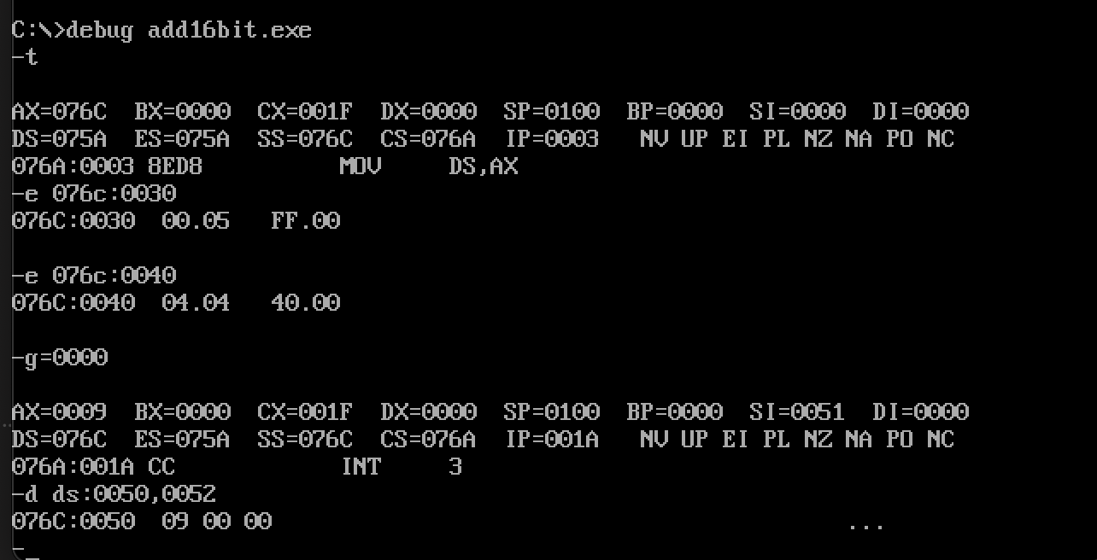

**Q2.)** **Write an Assembly Language Program to subtract an 8-bit numbers stored in DS: 0030H from a number stored in DS: 0040H using 2’s complement method. Store the result in DS: 0050H, and DS: 0051H.**

.model small  
.stack 100h  
.data  
.code  
main proc  
**mov** ax,@data  
**mov** ds,ax  
**mov** si,0030h  
**mov** al,[si]  
not al  
inc al  
**mov** si ,0040h  
**add** al,[si]  
  
jc L1  
not al  
inc al  
  
L1:  
**mov** si,0050h  
**mov** [si],al  
cmc  
**mov** ah,00h  
**adc** ah,ah  
inc si  
**mov** [si],ah  
  
  
int 03h  
main endp  
end main

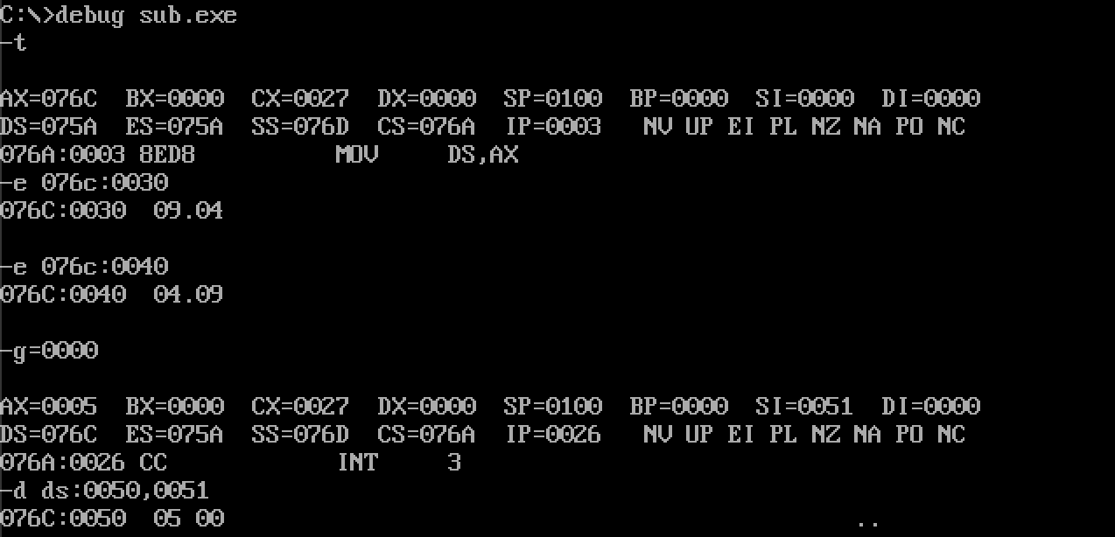

**Q3.)** **Write a program to transfer a block of 8 data bytes from memory location DS: 0030H to DS: 0040H.**

.model small  
.stack 100h  
.data  
.code  
main proc  
**mov** ax,@data  
**mov** ds,ax  
**mov** es,ax  
**mov** si,0030h  
**mov** di,0040h  
**mov** cx,0008h  
cld  
l1:**movsb**loop l1  
  
int 03h  
main endp  
end main

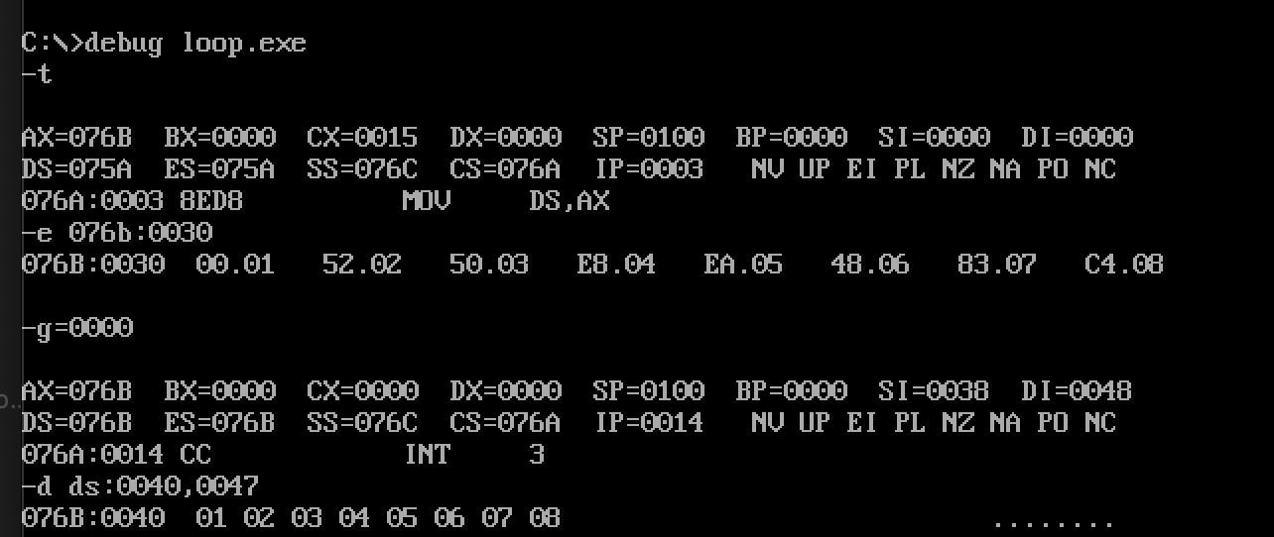

**Q4.)** **Write an 8086 Assembly Language Program for the addition of 7 eight-bit numbers stored from DS: 0030H. Store the result in DS: 0050H and DS: 0051H.**

.model small  
.stack 100h  
  
.data  
  
.code  
  
main proc  
**mov** ax,@data  
**mov** ds,ax  
**mov** al,00h  
**mov** ah,00h  
**mov** cl,07h  
**mov** si,0030h  
  
l1:  
**add** al,[si]  
**adc** ah,00h  
inc si  
loop l1  
  
**mov** si,0050h  
**mov** [si],al  
inc si  
**mov** [si],ah  
  
int 03h  
main endp  
end main

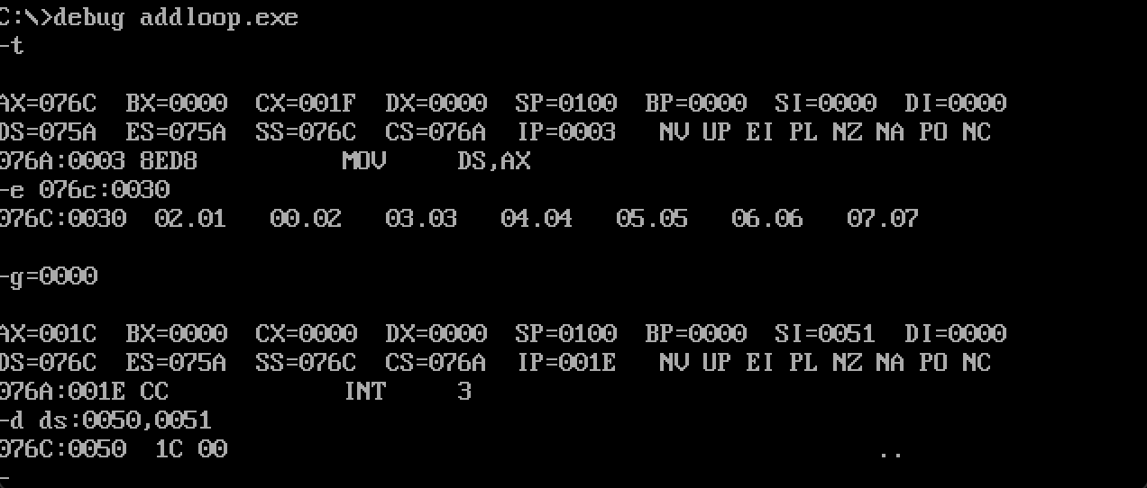

**Q5.)** **Write an 8086 Assembly Language Program for the addition of 5 sixteen-bit numbers stored from DS: 0030H. Store the result in DS: 0050H, DS: 0051H, DS: 0052H.**

..model small  
.stack 100h  
  
.data  
  
.code  
  
main proc  
**mov** ax,@data  
**mov** ds,ax  
**mov** ax,0000h  
**mov bl,00h  
mov** cl,05h  
**mov** si,0030h  
  
l1:  
**add** ax,[si]  
**adc bl,00h**inc si  
inc si  
loop l1  
  
**mov** si,0050h  
**mov** [si],ax  
inc si  
inc si  
**mov** [si],**bl**  
int 03h  
main endp  
end main

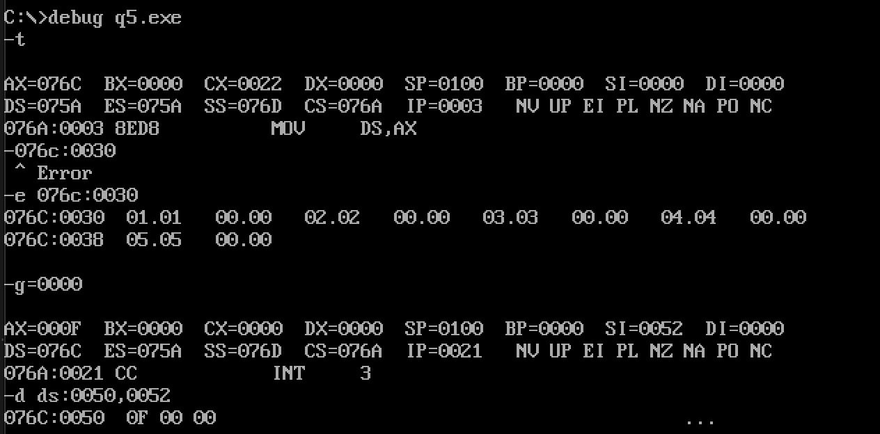

**Q6.)** **Write an Assembly Language Program for the addition of five BCD numbers stored from DS: 0030H. Store the result in DS: 0040H and DS: 0041H.**

.model small  
.stack 100h  
  
.data  
  
.code  
  
main proc  
**mov** ax,@data  
**mov** ds,ax  
**mov** ax,0000h  
**mov** cx,0005h  
**mov** si,0030h  
  
l1:  
**add** al,[si]  
daa  
**adc** ah,00h  
inc si  
loop l1  
  
**mov** si,0040h  
**mov** [si],ax  
  
int 03h  
main endp  
end main

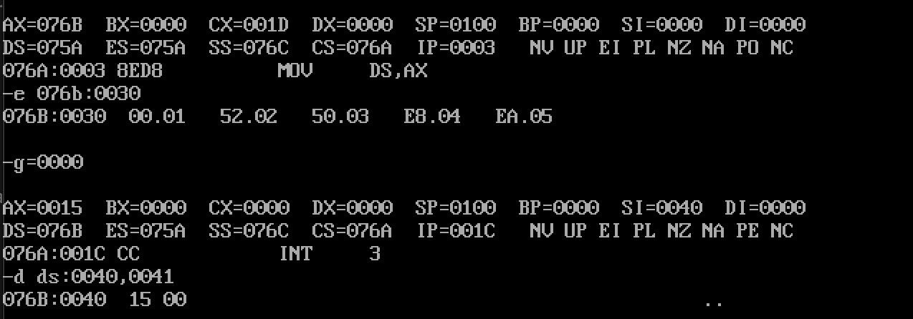

**Q7.)** **Write an Assembly Language Program to subtract a BCD number stored in DS:0040H from a BCD number stored in DS: 0050H. Store the result in DS: 0060H and DS: 0061H.**

.model small  
.stack 100h  
  
.data  
  
.code  
  
main proc  
**mov** ax,@data  
**mov** ds,ax  
**mov** ax,0000h  
  
  
**mov** si,0040h  
**mov** al,[si]  
**mov** si,0050h  
**sub** al,[si]  
das  
**mov** dl,00h  
jnc l1  
  
**mov** cl,al  
**mov** al,99h  
**sub** al,cl  
**add** al,01h  
daa  
**mov** dl,01h  
  
l1:  
**mov** si,0060h  
**mov** [si],al  
inc si  
**mov** [si],dl  
  
int 03h  
main endp  
end main

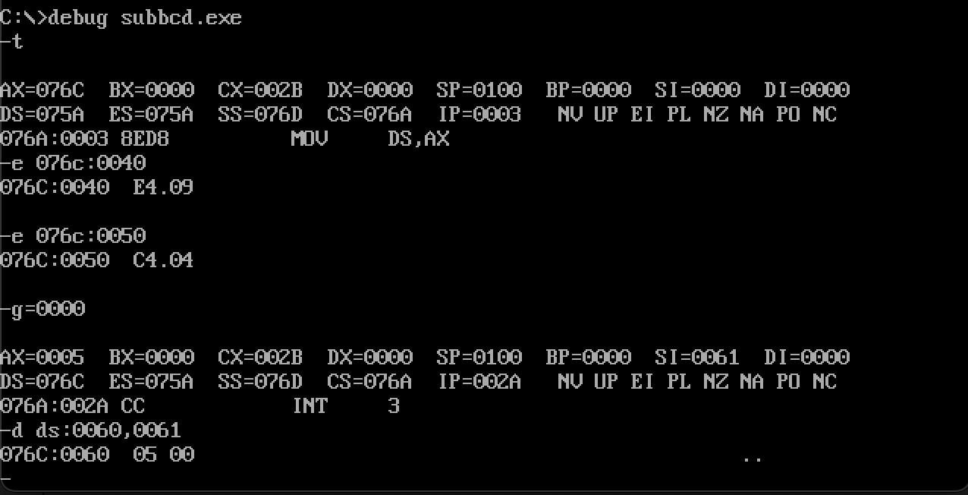

**Q8.)** **Write an Assembly Language Program to multiply two eight bit number stored in DS:0040H and DS: 0050H. Store the result from DS: 0060H.**

.model small  
.stack 100h  
  
.data  
  
.code  
  
main proc  
**mov** ax,@data  
**mov** ds,ax  
**mov** ax,0000h  
**mov bl,00h**  
**mov** si,0040h  
**mov** al,[si]  
**mov** si,0050h  
**mov bl,[si]  
mul bl**  
**mov** si,0060h  
**mov** [si],ax  
  
  
int 03h  
**mov** ah,4ch  
int 21h  
main endp  
end main

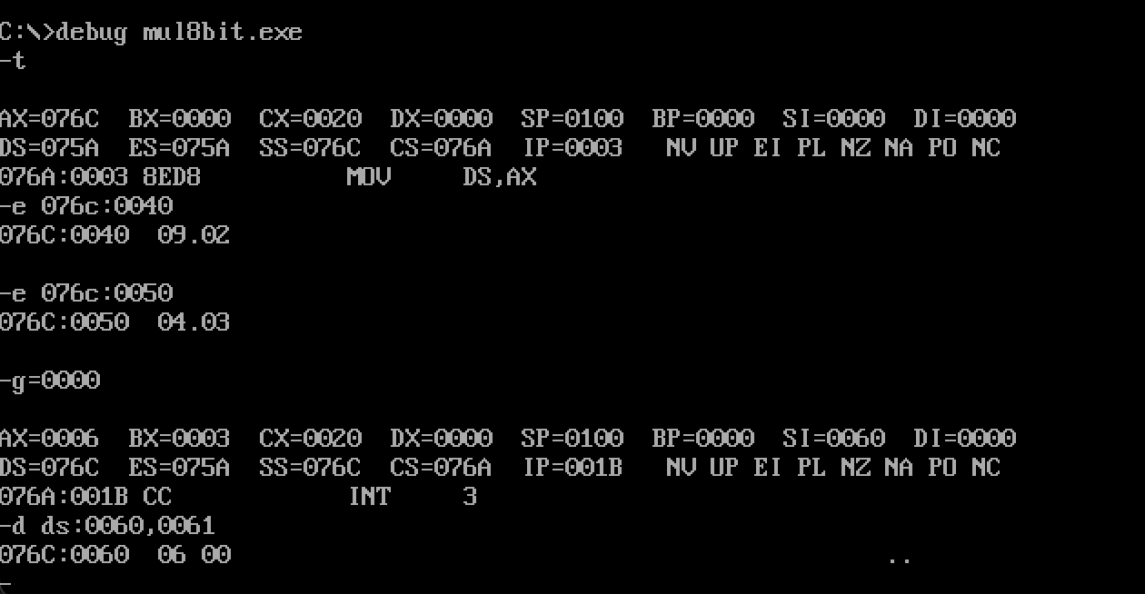

**Q9.)** **Write an Assembly Language Program to multiply two sixteen bit number stored in DS:0040H and DS:0050H. Store the result from DS: 0060H.**

.model small  
.stack 100h  
  
.data  
  
.code  
  
main proc  
**mov** ax,@data  
**mov** ds,ax  
**mov** ax,0000h  
**mov bx,0000h**  
  
**mov** si,0040h  
**mov** ax,[si]  
**mov** si,0050h  
**mov bx,[si]  
mul bx**  
**mov** si,0060h  
**mov** [si],ax  
inc si  
inc si  
**mov** [si],dx  
  
  
int 03h  
**mov** ah,4ch  
int 21h  
main endp  
end main

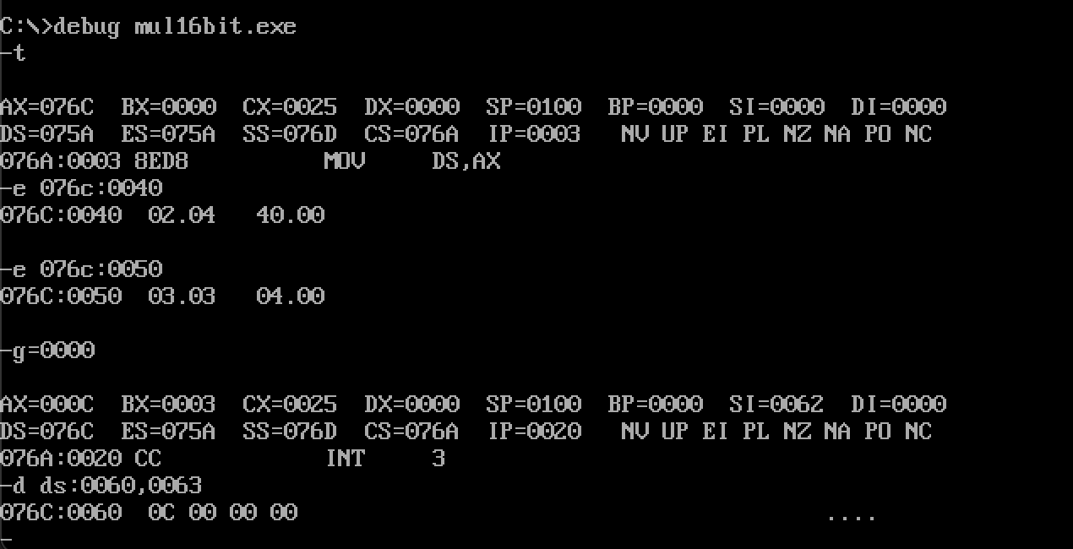

**Q10.)** **Write an Assembly Language Program to divide 88H by 33H. Store the quotient in DS: 0060H and remainder in DS: 0061H.**

.model small  
.stack 100h  
  
.data  
  
.code  
  
main proc  
**mov** ax,@data  
**mov** ds,ax  
**mov** ax,0000h  
  
**mov** al,88h  
**mov bl,33h**div **bl**  
**mov** si,0060h  
**mov** [si],ax  
  
int 03h  
**mov** ah,4ch  
int 21h  
main endp  
end main

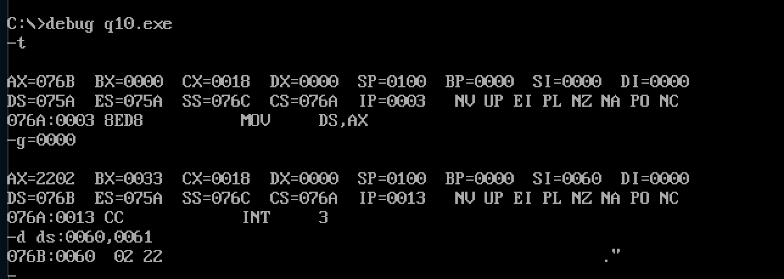

**Q11.)** **Write an Assembly Language Program to divide 2222H by 55H. Store the quotient from DS: 0060H and remainder in DS: 0062H.**

.model small  
.stack 100h  
  
.data  
  
.code  
  
main proc  
**mov** ax,@data  
**mov** ds,ax  
**mov** dx,0000h  
  
**mov** ax,2222h  
**mov bx,0055h**div **bx**  
**mov** si,0060h  
**mov** [si],ax  
inc si  
inc si  
**mov** [si],dx  
  
  
int 03h  
**mov** ah,4ch  
int 21h  
main endp  
end main

